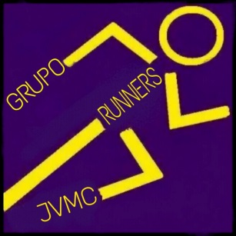
GRUPO RUNNERS JVMC
Clasificaciones
10k Alboraya contra el Cáncer
Puesto | Normbre | Carrera | Tiempo | Media
1 | Victor | 10k Alboraya | 00:47:22 | 4min44seg/ km
2 | Jose Luis | 10k Alboraya | 00:47:22 | 4min44seg/ km
3 | Emilio | 10k Alboraya | 00:50:24 | 5min02seg/ km
4 | Carlos | 10k Alboraya | 00:58:27 | 5min40seg/ km
5 | Mari Carmen | 10k Alboraya | 01:01:39 | 6min09seg/ km
6 | Maria Jose | 10k Alboraya | 01:03:19 | 6min19seg/ km
7 | Desi | 10k Alboraya | 01:03:20 | 6min20seg/ km
8 | Enrique | 10k Alboraya | 01:03:59 | 6min23seg/ km

